Absolute Haitian Job Postings
https://www.absolutehaitian.com/your-career
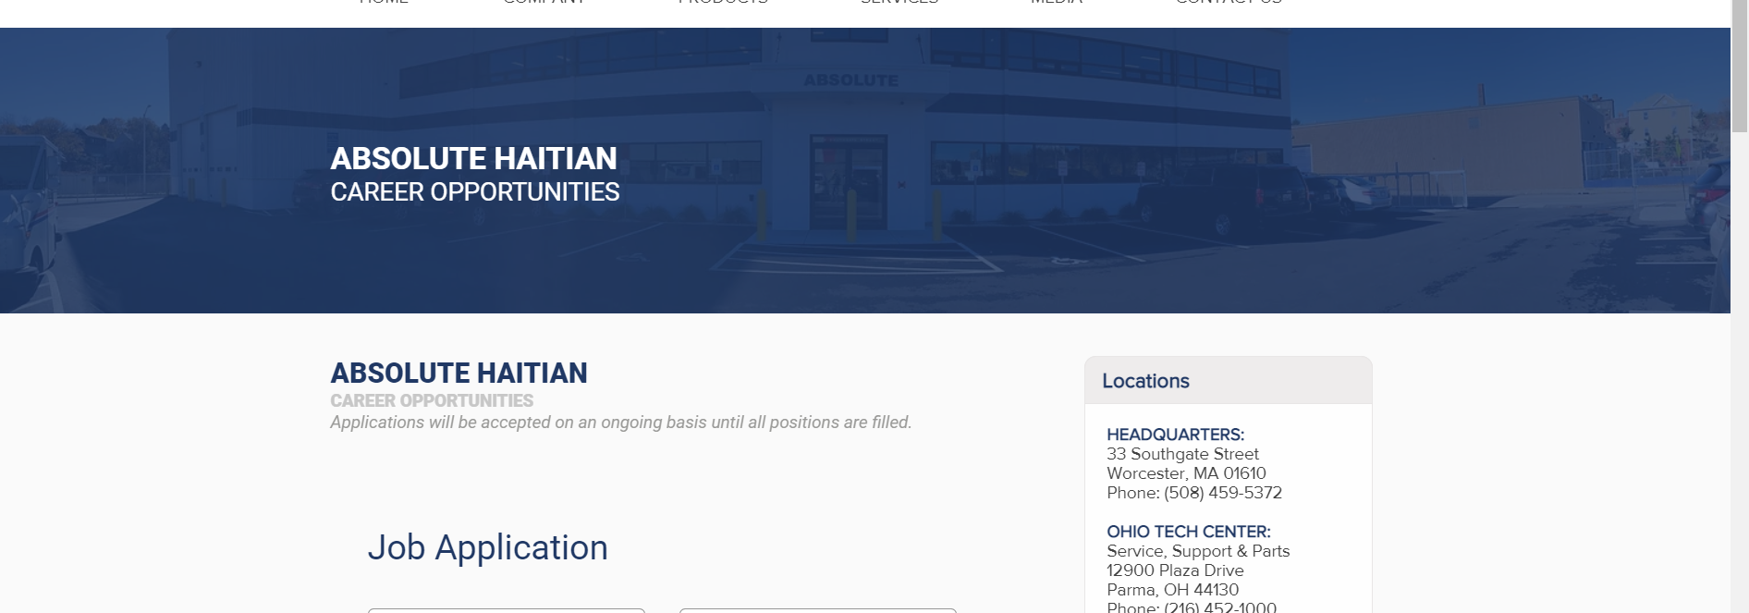
Underneath ABSOLUTE HAITIAN Career Opportunities, add a row where we can regularly put open positions. This would be above the “Job Application” form.
Right now, this is the position that should show:

Engineering Field Service Engineer Northern California and Texas
- These positions are responsible for direct machine start-up, repair service, and/or technical assistance at the customer’s facility or technical center to ensure customer satisfaction. We’re looking for a technically minded person who loves solving problems, has a customer-focused outlook and loves to travel. You’ll troubleshoot electrical, hydraulic and mechanical problems of new and used injection molding machinery.

Here’s how our competitor, Engel, shows it. I think it is a table in the row.
